## Front End Engineering-II

Project Report

Semester-IV (Batch-2022)

**TRAVEL AGENCY**

**(REACT)**



**Supervised By: Submitted By:**

Raveesh Samkaria Vinayak Sharma

2210990962

G-14

**Department of Computer Science and Engineering**

## Chitkara University Institute of Engineering & Technology,

## Chitkara University, Punjab

**Abstract**

The Travel Agency React project is a comprehensive web application designed to streamline the process of planning and booking travel experiences. Leveraging the power of React, this project aims to deliver a user-friendly interface that caters to both novice and experienced travellers. The application encompasses various features, including destination browsing, package selection, booking management, and user reviews, to ensure a seamless and engaging user experience.

At the core of this project is a dynamic and responsive front-end interface built using React. This framework's component-based architecture allows for efficient development and maintenance, ensuring that the application remains scalable and easy to update. The user interface is designed with a focus on intuitive navigation and accessibility, providing users with effortless access to a wealth of travel information and options. Key components include a search bar for quick destination lookups, detailed destination pages with rich media content, and an interactive booking system that guides users through the process of selecting and reserving travel packages.

To enhance functionality, the Travel Agency project integrates various APIs and third-party services. These integrations allow for real-time data fetching and updates, ensuring that users receive the most current information regarding travel destinations, availability, and pricing. Additionally, the application employs state management solutions such as Redux to handle complex data flows and maintain application state across different components. This ensures a consistent user experience and enables features like user authentication, personalized recommendations, and booking history tracking.

**Table of Contents**

|  |  |  |  |
| --- | --- | --- | --- |
| **S No.** | **Contents** | **Page No** | **Remarks** |
| 1. | Introduction   * Background * Objectives * Significance | 4-6 |  |
| 2. | Problem Definition and Requirements   * Problem Statement * Software Requirements * Hardware Requirements | 7-9 |  |
| 3. | Proposed Design / Methodology   * Design Concept * Methodology * File Structure | 10-12 |  |
| 4. | Code   * HTML/JSX * CSS | 13-61 |  |
| 5. | Results   * Screenshots | 62-66 |  |
| 6. | References | 67 |  |

1. **Introduction**
   * **Background**

The Travel Agency is conceived in response to the evolving landscape of the travel industry, where digital transformation has become a key driver of growth and customer satisfaction. As travellers increasingly rely on online resources to plan their journeys, the need for intuitive, efficient, and comprehensive digital platforms has become more pronounced. This project leverages the capabilities of React, a powerful JavaScript library for building user interfaces, to create a sophisticated travel booking application that meets these modern demands.

The background of this project is deeply intertwined with the advancements in web development technologies. React, developed by Facebook, is renowned for its component-based architecture, which promotes reusability and ease of maintenance. This makes it an ideal choice for developing complex applications like travel booking systems, which require seamless integration of multiple features and a dynamic user experience. By utilizing React, the project ensures that the application is not only scalable but also capable of delivering high performance and a responsive design, essential for engaging today's tech-savvy travellers.

Moreover, this project highlights the importance of user-centric design in the travel industry. By incorporating modern UI/UX principles and ensuring cross-device compatibility, the Travel Agency React application aims to provide a seamless and enjoyable user journey. The inclusion of user feedback mechanisms further enriches the platform, fostering a community-driven environment where travellers can share their insights and experiences. In essence, the Travel Agency React project not only meets the current needs of travellers but also sets a precedent for future developments in digital travel solutions, underscoring the transformative power of web technologies in enhancing the travel experience.

* + **Objectives**

**User-Friendly Interface:**

The primary objective of the Travel Agency React project is to develop a user-friendly interface that simplifies the travel planning process for users of all backgrounds. This entails creating an intuitive navigation system, visually appealing design elements, and easy-to-understand features. By prioritizing user experience, the application aims to enhance engagement and satisfaction among travellers.

**Comprehensive Destination Information:**

Another key objective is to provide users with comprehensive information about various travel destinations. This includes detailed descriptions, high-quality images, lists of local attractions, and practical travel tips. By offering a wealth of information, the application empowers users to make informed decisions and discover new destinations that align with their interests and preferences.

**Responsive Design:**

Ensuring a seamless experience across devices is paramount, and therefore the project focuses on creating a fully responsive design. By adhering to modern web design principles and utilizing responsive design techniques, the application maintains usability and aesthetics on various screen sizes, from desktops to mobile devices.

* + **Significance**

**Enhanced User Experience:**

The Travel Agency React project significantly enhances the user experience by providing a modern, intuitive, and visually appealing platform for travel planning. This user-centric approach ensures that travellers can easily navigate the application, access comprehensive information, and complete bookings efficiently. By prioritizing user experience, the project aims to increase user satisfaction and engagement, making travel planning more enjoyable and less stressful.

**Accessibility and Convenience:**

One of the key significances of the project is its ability to offer accessibility and convenience to travellers. Unlike traditional travel agencies that may have limited operating hours and require physical visits, this online platform is available 24/7 from any location. This accessibility allows users to plan and book their trips at their convenience, catering to the needs of today's busy and mobile lifestyle.

**Scalability and Future-Proofing:**

The project's emphasis on scalability and maintainability ensures that the platform can grow and adapt to future demands and technological advancements. This forward-thinking approach allows for the continuous addition of new features and improvements, keeping the application relevant and competitive in the ever-evolving travel industry. By designing for scalability, the project sets the stage for long-term success and sustainability.

1. **Problem Definition and Requirements**
   * **Problem Statement**

**Fragmented Services and User Experience:**

The current landscape of travel planning and booking is often fragmented, with users needing to visit multiple websites or apps to gather information, compare options, and make reservations. This fragmentation leads to a disjointed user experience, making it difficult for travellers to plan their trips efficiently and effectively.

**Outdated Interfaces and Poor Usability:**

Many existing travel platforms suffer from outdated interfaces that are not user-friendly. Poor navigation, cluttered layouts, and non-responsive designs contribute to a frustrating user experience, particularly on mobile devices. Travelers need a modern, intuitive interface that simplifies the planning and booking process.

**Lack of Real-Time Information:**

Travel plans often require up-to-date information on availability, pricing, and travel advisories. Many existing platforms fail to provide real-time data, leading to issues such as booking errors, price discrepancies, and outdated travel information. There is a need for a solution that integrates real-time data to ensure accuracy and reliability.

* + **Software Requirements**

**Web Browser:** The Travel Agency website is designed to be accessed via web browsers. It is compatible with modern browsers such as Google Chrome, Mozilla Firefox, Safari, and Microsoft Edge. Users should have a stable internet connection to access the website seamlessly.

**Code Editor:** Developers working on the Travel Agency website project require a code editor for editing HTML, CSS, and JavaScript files. Recommended code editors include Visual Studio Code, Sublime Text, Atom, and Brackets. These editors provide features such as syntax highlighting, code completion, and debugging tools to facilitate efficient development.

**React and Vite:** The Travel Agency website is built using React for creating dynamic user interfaces and Vite for fast development and hot module replacement. Developers should have Node.js installed on their systems to install and manage project dependencies using npm or Yarn.

**Operating System:** The Travel Agency website project can be developed and run on various operating systems, including Windows, macOS, and Linux. Developers should ensure that their operating system is up-to-date and compatible with the required development tools and dependencies.

**Internet Connection:** An internet connection is required for accessing documentation, downloading dependencies, and testing the Travel Agency website in a web browser environment. Developers should have a stable internet connection to facilitate efficient development and collaboration.

* + **Hardware Requirements**

The hardware requirements for running the project are relatively minimal and include the following:

* + - **Processor:** A multi-core processor, such as an Intel Core i5 or AMD Ryzen equivalent, is recommended for optimal performance during development and testing.
    - **Memory (RAM):** A minimum of 4 GB of RAM is recommended for running development tools, code editors, web browsers, and other software concurrently.
    - **Storage:** Sufficient storage space is needed to store project files, code, assets, and dependencies. A solid-state drive (SSD) is preferred for faster read/write speeds and improved performance.
    - **Input Devices:** A keyboard and mouse (or trackpad) are essential for interacting with the computer and navigating the development environment.
    - **Internet Connection:** An internet connection is required for accessing documentation, downloading dependencies, and running the website in a web browser environment.

1. **Proposed Design/Methodology**
   * **Design Concept**

**Requirement Analysis:** The methodology begins with a comprehensive analysis of user requirements, preferences, and expectations for the Travel Agency travelling website. This involves gathering feedback from potential customers, studying competitor websites, and identifying key features essential for the success of the website. User surveys, interviews, and market research are conducted to gain insights into user needs and industry trends in the travelling landscape.

**Frontend Development:** The frontend development phase focuses on implementing the user interface design using React. Responsive layouts are created to ensure compatibility across various devices and screen sizes. Styling interface elements is done using frameworks like Bootstrap or custom CSS, adhering to the design principles established during the prototyping phase. Interactive features such as menus, reservation forms, and gallery sliders are implemented using JavaScript libraries to enhance user engagement.

**Testing and Quality Assurance:** Throughout the development process, rigorous testing and quality assurance measures are employed to identify and address any issues or bugs. Functional testing is conducted to ensure that all features work as intended, including forms submission, menu navigation, and image galleries. Compatibility testing is performed to verify cross-browser and cross-device compatibility, ensuring a consistent user experience across different platforms. Performance testing is carried out to optimize page load times and responsiveness, enhancing overall website performance.

* + **Methodology**

**Requirement Analysis:** The methodology initiates with an in-depth analysis of user needs, preferences, and expectations for the Travel Agency travelling website. Through surveys, interviews, and market research, we gather insights into customer behaviours, competitor benchmarks, and industry trends. This phase aims to identify essential features and functionalities crucial for creating an effective online presence for the travelling.

**Frontend Development:** With approved prototypes in hand, the frontend development phase begins. Using React we translate the design concepts into interactive web pages. Special attention is given to responsive design principles to ensure compatibility across various devices and screen sizes. The user interface elements are styled to reflect the travelling's branding and ambiance, creating a cohesive visual identity.

By adhering to this methodology, the Travel Agency website project aims to deliver an engaging, user-friendly online platform that effectively showcases the travelling's offerings, enhances customer engagement, and reinforces its brand presence in the competitive travelling landscape.

* + **File Structure**

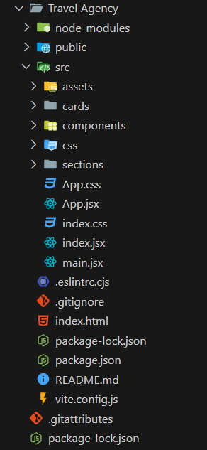

**HTML**

* Components
  + Header.jsx

import "../css/Header.css";

import {

   phoneIcon,

   mailIcon,

   facebook,

   google,

   vk,

   youtube,

   user,

   key,

} from "../assets";

function Header() {

   return (

      <header>

         <div className="headerTop">

            <div className="contact">

               <div className="phone">

                  <img src={phoneIcon} alt="" width={20} />

                  <h2>+123 456 789</h2>

               </div>

               <div className="mail">

                  <img src={mailIcon} alt="" width={20} />

                  <h2>free @psdfreebies.com</h2>

               </div>

            </div>

            <div className="headerTopRight">

               <div className="icons">

                  <ul>

                     <li>

                        <a href="">

                           <img src={facebook} alt="" width={20} />

                        </a>

                     </li>

                     <li>

                        <a href="">

                           <img src={google} alt="" width={30} />

                        </a>

                     </li>

                     <li>

                        <a href="">

                           <img src={vk} alt="" width={30} />

                        </a>

                     </li>

                     <li>

                        <a href="">

                           <img src={youtube} alt="" width={20} />

                        </a>

                     </li>

                  </ul>

               </div>

               <div className="accounts">

                  <div className="login">

                     <img src={user} width={20} alt="" />

                     <h2>Login</h2>

                  </div>

                  <div className="signup">

                     <img src={key} width={20} alt="" />

                     <h2>SignUp</h2>

                  </div>

               </div>

            </div>

         </div>

         <hr />

         <div className="headerBottom">

            <div className="headline">

               <h1>Explore</h1>

               <h2>CREATIVE TAGLINE HERE</h2>

            </div>

            <div className="links">

               <ul>

                  <li>

                     <a href="" className="active">

                        HOME

                     </a>

                  </li>

                  <li>

                     <a href="">DESTINATION</a>

                  </li>

                  <li>

                     <a href="">DISCOUNT</a>

                  </li>

                  <li>

                     <a href="">ABOUT</a>

                  </li>

                  <li>

                     <a href="">BLOG</a>

                  </li>

                  <li>

                     <a href="">CONTACT</a>

                  </li>

               </ul>

            </div>

         </div>

      </header>

   );

}

export default Header;

* + FindHotels.jsx

import "../css/FindHotels.css";

export default function FindHotels() {

   return (

      <>

         <div className="hotelFinder">

            <h1>FIND HOTELS</h1>

            <div className="form">

               <div className="where">

                  <h1>Where?</h1>

                  <input type="text" placeholder="Location" />

               </div>

               <div className="checkIn">

                  <h1>Check In</h1>

                  <input type="date" placeholder="DD-MM--YY" />

               </div>

               <div className="checkOut">

                  <h1>Check Out</h1>

                  <input type="date" placeholder="DD-MM--YY" />

               </div>

               <div className="adult">

                  <h1>Adult</h1>

                  <input type="text" placeholder="01" />

               </div>

               <div className="child">

                  <h1>Child</h1>

                  <input type="text" placeholder="00" />

               </div>

               <div className="hotelButton">

                  <button>Click Here</button>

               </div>

            </div>

         </div>

      </>

   );

}

* + Services.jsx

const serviceCard = ({

   image,

   budget,

   rate,

   checkIcon,

   listitem1,

   listitem2,

   listitem3,

   listitem4,

}) => {

   return (

      <>

         <div>

            <img src={image} alt="" />

            <h1>{budget}</h1>

            <h2>{rate}</h2>

            <ul>

               <li>

                  <img src={checkIcon} alt="" />

                  {listitem1}

               </li>

               <li>

                  <img src={checkIcon} alt="" />

                  {listitem2}

               </li>

               <li>

                  <img src={checkIcon} alt="" />

                  {listitem3}

               </li>

               <li>

                  <img src={checkIcon} alt="" />

                  {listitem4}

               </li>

            </ul>

         </div>

      </>

   );

};

export default serviceCard;

* + BestServices.jsx

const BestServices = ({ image, title, description }) => {

   return (

      <>

         <div className="serviceIcon">

            <img src={image} alt="" />

            <div>

               <h1>{title}</h1>

               <h2>{description}</h2>

            </div>

         </div>

      </>

   );

};

export default BestServices;

* + Locations.jsx

const Locations = ({ image, days, location, about, price, click }) => {

   return (

      <>

         <div className="ThreeLocations">

            <img src={image} alt="" />

            <div>

               <h1>{days}</h1>

               <h2>{location}</h2>

               <p>{about}</p>

               <h3>{price}</h3>

               <button>{click}</button>

            </div>

         </div>

      </>

   );

};

export default Locations;

* + Looks.jsx

const LooksCard = ({ image, click, title, description }) => {

   return (

      <>

         <div className="blog">

            <img src={image} alt="" />

            <div>

               <button>{click}</button>

               <div className="blogdiv">

                  <h1>{title}</h1>

                  <p>{description}</p>

               </div>

            </div>

         </div>

      </>

   );

};

export default LooksCard;

* + Footer.jsx

import "../css/Footer.css";

import { pin, email, mobile, gps } from "../assets";

import {

   facebookBlack,

   googleBlack,

   vkBlack,

   youtubeBlack,

   linkedinBlack,

   diggBlack,

   xblack,

} from "../assets";

function Index() {

   return (

      <>

         <footer>

            <div className="logo">

               <div className="head">

                  <h1>Start Your Jorney</h1>

                  <h2>Contact Us</h2>

               </div>

               <div className="logo-img">

                  <img src={pin} alt="" width={50} />

               </div>

               <div className="content">

                  <div className="contact-mail">

                     <img src={email} alt="" />

                     <div className="mail-text">

                        <h1>EMail</h1>

                        <h2>free@address.com</h2>

                        <h2>free@address.com</h2>

                     </div>

                  </div>

                  <div className="contact-us">

                     <img src={mobile} alt="" />

                     <div className="contact-text">

                        <h1>Call Us!</h1>

                        <h2>+123 456 789</h2>

                        <h2>+123 456 789</h2>

                     </div>

                  </div>

                  <div className="contact-add">

                     <img src={gps} alt="" />

                     <div className="add-text">

                        <h1>Address</h1>

                        <h2>123, Main Road City,</h2>

                        <h2>My Country 123456</h2>

                     </div>

                  </div>

               </div>

            </div>

            <div className="social-media-icons">

               <img src={facebookBlack} alt="" />

               <img src={googleBlack} alt="" />

               <img src={vkBlack} alt="" />

               <img src={youtubeBlack} alt="" />

               <img src={linkedinBlack} alt="" />

               <img src={diggBlack} alt="" />

               <img src={xblack} alt="" />

            </div>

            <div className="designedby">

               <h1>Designed by PSDFreebies.com</h1>

               <h1>Copyright 2020, All Right Reserved</h1>

            </div>

         </footer>

      </>

   );

}

export default Index;

* Sections
  + FindHotels.jsx

import "../css/FindHotels.css";

export default function FindHotels() {

   return (

      <>

         <div className="hotelFinder">

            <h1>FIND HOTELS</h1>

            <div className="form">

               <div className="where">

                  <h1>Where?</h1>

                  <input type="text" placeholder="Location" />

               </div>

               <div className="checkIn">

                  <h1>Check In</h1>

                  <input type="date" placeholder="DD-MM--YY" />

               </div>

               <div className="checkOut">

                  <h1>Check Out</h1>

                  <input type="date" placeholder="DD-MM--YY" />

               </div>

               <div className="adult">

                  <h1>Adult</h1>

                  <input type="text" placeholder="01" />

               </div>

               <div className="child">

                  <h1>Child</h1>

                  <input type="text" placeholder="00" />

               </div>

               <div className="hotelButton">

                  <button>Click Here</button>

               </div>

            </div>

         </div>

      </>

   );

}

* + Locations.jsx

import "../css/Location.css";

import { locations } from "../cards/locations";

import Locations from "../components/Locations";

import { looks } from "../cards/looks";

import LooksCard from "../components/Looks";

export default function Location() {

   return (

      <>

         <div className="TouristLocations">

            <div className="packAndGo">

               <h1>Pack and GO</h1>

               <h2>Awesome Tours</h2>

            </div>

            <div className="locationdiv">

               {locations.map((item, index) => (

                  <Locations

                     key={index}

                     image={item.image}

                     days={item.days}

                     location={item.location}

                     about={item.about}

                     price={item.price}

                     click={item.click}

                  />

               ))}

            </div>

         </div>

         <div className="areaLooks">

            <div className="looksText">

               <h1>Trusted Since 2001</h1>

               <h2>GO EXPLOORE</h2>

            </div>

            <div className="looksdiv">

               {looks.map((item, index) => (

                  <LooksCard

                     key={index}

                     image={item.image}

                     click={item.click}

                     title={item.title}

                     description={item.description}

                  />

               ))}

            </div>

         </div>

      </>

   );

}

* + Reviews.jsx

import "../css/Reviews.css";

import { star, avatar } from "../assets";

export default function Reviews() {

   const array = new Array(5).fill(0);

   return (

      <>

         <div className="review">

            <div>

               <h1>Customer Reviews</h1>

               <h2>We are Travel Agent</h2>

            </div>

            <div className="reviewText">

               <p>

                  "Lorem ipsum dolor sit amet consectetur adipisicing elit.

                  Temporibus deleniti dolore autem hic reiciendis est doloremque

                  sequi molestias recusandae. Fugiat in, praesentium excepturi

                  suscipit aliquid adipisci est consequuntur ea corporis."

               </p>

               <div className="stars">

                  {array.map((_, index) => (

                     <img key={index} src={star} alt="star" />

                  ))}

               </div>

            </div>

            <div className="profile">

               <img src={avatar} alt="" />

               <div>

                  <h3>John Smith</h3>

                  <h4>Solo Traveller</h4>

               </div>

            </div>

         </div>

      </>

   );

}

* + Services.jsx

import "../css/Services.css";

import { train, check } from "../assets";

import Card from "../components/Services";

import { serviceItems } from "../cards/serviceItems";

import { bestServices } from "../cards/bestServices";

import BestServices from "../components/BestServices";

export default function Services() {

   return (

      <>

         <div className="services">

            <img src={train} alt="" />

            <div className="pattern">

               <h1>Trusted Since 2001</h1>

               <h2>We are Exploore</h2>

               <h3>

                  Lorem ipsum dolor sit amet consectetur adipisicing elit. Rerum

                  iure officiis ipsam ipsa eos, quibusdam quo necessitatibus

                  modi iusto minus eum accusamus voluptas et facilis! Optio,

                  omnis

               </h3>

               <div className="points">

                  <div>

                     <img src={check} alt="" />

                     <h1>

                        Lorem ipsum dolor sit amet consectetur adipisicing elit.

                        Distinctio, repellat.

                     </h1>

                  </div>

                  <div>

                     <img src={check} alt="" />

                     <h1>

                        Lorem ipsum dolor sit amet consectetur adipisicing elit.

                        Distinctio, repellat.

                     </h1>

                  </div>

                  <div>

                     <img src={check} alt="" />

                     <h1>

                        Lorem ipsum dolor sit amet consectetur adipisicing elit.

                        Distinctio, repellat.

                     </h1>

                  </div>

               </div>

            </div>

         </div>

         <div className="bestService">

            <div className="ourbest">

               <h1>Our Best Services</h1>

               <h2>We are Travel Agent</h2>

            </div>

            <div className="best-Services">

               {bestServices.map((item, index) => (

                  <BestServices

                     key={index}

                     image={item.image}

                     title={item.title}

                     description={item.description}

                  />

               ))}

            </div>

         </div>

         <div className="budgets">

            <div>

               <h1>Trusted Since</h1>

               <h2>We are Trusted Agent</h2>

            </div>

            <div className="budget">

               {serviceItems.map((item, index) => (

                  <Card

                     key={index}

                     image={item.image}

                     budget={item.budget}

                     rate={item.rate}

                     checkIcon={item.checkIcon}

                     listitem1={item.listItem1}

                     listitem2={item.listItem2}

                     listitem3={item.listItem3}

                     listitem4={item.listItem4}

                  />

               ))}

            </div>

         </div>

      </>

   );

}

* + Sponsored.jsx

import { plane, bank, car, shed } from "../assets";

import "../css/Sponsored.css";

export default function Sponsored() {

   return (

      <>

         <div className="sponsor">

            <img src={shed} alt="" />

            <div className="sponsorContent">

               <div>

                  <h1>New York + Paris</h1>

                  <h2>7 Day + 6 Night</h2>

               </div>

               <div className="sponsoredIcons">

                  <ul>

                     <li>

                        <img src={plane} alt="" />

                        Flight

                     </li>

                     <li>

                        <img src={bank} alt="" />

                        Hotel

                     </li>

                     <li>

                        <img src={car} alt="" />

                        Transport

                     </li>

                  </ul>

               </div>

               <p>

                  Lorem ipsum dolor sit amet consectetur adipisicing elit.

                  Totam, accusamus. Placeat, numquam iste. Inventore animi hic

                  vel illo magnam dignissimos?

               </p>

               <div className="priceandbutton">

                  <h3>$1000</h3>

                  <button>BOOK NOW</button>

               </div>

            </div>

         </div>

      </>

   );

}

* + TravelSince.jsx

import "../css/TravelSince.css";

import { man } from "../assets";

import { planeWhite, carBlack, bank } from "../assets";

export default function TravelSince() {

   return (

      <>

         <div className="travelSince">

            <div className="leftSection">

               <img src={man} alt="" />

            </div>

            <div className="rightSection">

               <div>

                  <h1>Trusted Since 2001</h1>

                  <h2>We are Travel Agent</h2>

               </div>

               <div className="travelFlow">

                  <ul>

                     <li className="travelFlow-plane">

                        <img src={planeWhite} alt="" />

                        Plane

                     </li>

                     <li className="travelFlow-cab">

                        <img src={carBlack} alt="" />

                        Cab

                     </li>

                     <li>

                        <img src={bank} alt="" />

                        Hotel

                     </li>

                  </ul>

               </div>

               <div>

                  <p>

                     Lorem ipsum dolor sit amet consectetur adipisicing elit. Et

                     quidem quam voluptatibus. Consequuntur quidem quam minus

                     earum ab. Deserunt adipisci blanditiis rem iusto voluptatum

                     quod delectus tenetur laboriosam inventore, perferendis

                     temporibus quidem laudantium eos nostrum quas quos iste

                     veniam eum assumenda! Natus, cumque et quas sit magni

                     impedit in voluptate, quaerat, eos voluptatem provident

                     doloremque? Odio, rerum repellat, sit est esse

                  </p>

               </div>

               <button>Click Here</button>

            </div>

         </div>

      </>

   );

}

CSS

* + FindHotel.css

.hotelFinder {

   background-color: #f0d839;

   opacity: 1;

   background-size: 7px 7px;

   background-image: repeating-linear-gradient(

      45deg,

      #c9c971 0,

      #c9c971 0.7000000000000001px,

      #f0d839 0,

      #f0d839 50%

   );

   display: flex;

   align-items: center;

   flex-direction: column;

   padding: 50px;

}

.hotelFinder h1 {

   font-size: 37px;

   letter-spacing: 0px;

   color: #000000;

   font-weight: 900;

   font-family: "Montserrat";

   padding-bottom: 50px;

}

.form {

   display: flex;

   align-items: flex-end;

   gap: 15px;

}

.form h1 {

   font-size: 18px;

   letter-spacing: 0px;

   color: #000000;

   font-weight: 500;

   font-family: "Montserrat";

   padding-bottom: 10px;

}

.form input {

   border: none;

   border-radius: 5px;

   padding: 7px 15px;

}

.adult input,

.child input {

   width: 75px;

}

.form button {

   font-size: 14px;

   letter-spacing: 0px;

   text-transform: uppercase;

   color: #ffffff;

   font-weight: 500;

   font-family: "Montserrat";

   text-align: center;

   background-image: linear-gradient(180deg, #4d4d4d 0%, #494949 100%);

   border: none;

   padding: 7px 30px;

   border-radius: 5px;

}

@media screen and (max-width: 900px) {

   .form {

      display: grid;

      grid-template-columns: 1fr 1fr;

   }

}

@media screen and (max-width: 425px) {

   .form {

      display: flex;

      flex-direction: column;

      align-items: baseline;

   }

}

* + Footer.css

.logo {

   background: url("../assets/backgrounds/FooterBg.png");

   display: flex;

   flex-direction: column;

   align-items: center;

   justify-content: center;

}

.head {

   color: #fff;

   padding-top: 150px;

   padding-bottom: 100px;

}

.head h1 {

   font-size: 37px;

   font-weight: 700;

   font-family: "Montserrat";

   text-align: center;

}

.head h2 {

   font-size: 32px;

   font-weight: 400;

   text-align: center;

}

.logo-img img {

   position: absolute;

   width: 150px;

   translate: -50%;

}

.content {

   margin-top: 130px;

   padding-top: 100px;

   background: #fff;

   width: 100%;

   display: flex;

   justify-content: space-around;

}

.content h1 {

   font-size: 17px;

   letter-spacing: 0px;

   text-transform: uppercase;

   color: #262626;

   font-weight: 700;

   font-family: "Lato";

}

.content h2 {

   font-size: 16px;

   letter-spacing: 0px;

   color: #262626;

   font-weight: 400;

   font-family: "Lato";

}

.contact-mail,

.contact-us,

.contact-add {

   display: flex;

   align-items: flex-start;

   gap: 30px;

}

.social-media-icons {

   display: flex;

   align-items: center;

   justify-content: center;

   flex-wrap: wrap;

   gap: 30px;

   padding: 100px 25px 75px 25px;

}

.social-media-icons img {

   border-radius: 50%;

   padding: 10px;

   border: 3px solid #f0d839;

   aspect-ratio: 3/2;

   object-fit: contain;

   width: 40px;

   height: 40px;

}

.designedby {

   background-color: #f0d839;

   padding: 25px;

}

.designedby h1 {

   font-size: 17px;

   letter-spacing: 0px;

   line-height: 50px;

   color: #000000;

   font-weight: 700;

   font-family: "Lato";

   text-align: center;

}

@media screen and (max-width: 675px) {

   .logo {

      background-size: cover;

   }

   .content {

      display: flex;

      flex-direction: column;

      align-items: center;

      gap: 30px;

   }

}

* + Header.css

@import url("https://fonts.googleapis.com/css2?family=Montserrat:ital,wght@0,100..900;1,100..900&display=swap");

* {

   margin: 0;

   padding: 0;

   font-family: "Montserrat", sans-serif;

}

body,

html {

   width: 100%;

}

header {

   /* margin-top: 10px; */

   padding: 17px 12vw;

   background-color: rgba(0, 0, 0, 0.388);

   color: #fff;

}

.headerTop {

   display: flex;

   justify-content: space-between;

   align-items: center;

   font-size: 9px;

}

.contact {

   display: flex;

   align-items: center;

   gap: 7vw;

}

.contact > div {

   gap: 10px;

}

.headerTopRight {

   display: flex;

   gap: 8vw;

}

.icons {

   display: flex;

}

.icons ul {

   display: flex;

   gap: 16px;

}

.accounts {

   display: flex;

   /* width: 15%; */

   justify-content: space-between;

   gap: 10px;

}

.accounts > div {

   gap: 10px;

}

.phone,

.mail,

.icons,

ul,

li,

a,

.accounts,

.login,

.signup {

   display: flex;

   align-items: center;

   list-style: none;

   text-decoration: none;

}

hr {

   /* width: 80%; */

   border: none;

   height: 3px;

   background: #fff;

   opacity: 0.388;

   margin: 10px 0;

}

.headerBottom {

   display: flex;

   justify-content: space-between;

   align-items: center;

}

.headline {

   display: flex;

   flex-direction: column;

}

.headline h1 {

   margin: 0;

   font-size: 33px;

}

.headline h2 {

   font-size: 12px;

}

.links ul {

   display: flex;

   gap: 2vw;

}

.links ul li {

   font-size: 16px;

}

.links ul li a {

   color: #fff;

   font-weight: 500;

}

.links .active {

   text-decoration: underline;

   text-decoration-color: #ffdd00;

   text-underline-offset: 4.25vh;

   text-decoration-thickness: 5px;

}

@media screen and (max-width: 768px) {

   header {

      display: flex;

      align-items: center;

      flex-direction: column;

   }

   .phone,

   .mail,

   .links {

      display: none;

   }

}

@media screen and (max-width: 375px) {

   .accounts h2 {

      font-size: 8px;

   }

}

* + Location.css

.TouristLocations {

   background: url("../assets/backgrounds/scenery.png");

   background-size: cover;

   background-repeat: no-repeat;

   display: flex;

   flex-direction: column;

   align-items: center;

   padding: 20px 0;

}

.TouristLocations h1 {

   font-size: 37px;

   color: #000000;

   font-weight: 900;

   font-family: "Montserrat";

   text-align: center;

   padding-bottom: 10px;

}

.TouristLocations h2 {

   font-size: 37px;

   color: #000000;

   font-weight: 600;

   font-family: "Montserrat";

   text-align: center;

}

.packAndGo,

.locationdiv {

   padding-top: 30px;

}

.locationdiv {

   display: flex;

   align-items: center;

   margin-bottom: 100px;

}

.ThreeLocations {

   overflow: hidden;

   box-shadow: rgba(0, 0, 0, 0.19) 0px 10px 20px,

      rgba(0, 0, 0, 0.23) 0px 6px 6px;

   border-radius: 10px;

}

.ThreeLocations:nth-child(1) {

   background: #fff;

   width: min-content;

   translate: 10px;

}

.ThreeLocations:nth-child(2) {

   background: #fff;

   width: min-content;

   z-index: 99;

   border-radius: 10px 10px 0 0;

}

.ThreeLocations:nth-child(2)::after {

   content: "";

   position: absolute;

   box-shadow: rgba(0, 0, 0, 0.19) 0px 10px 20px,

      rgba(0, 0, 0, 0.23) 0px 6px 6px;

   background: #fff;

   height: 307px;

   z-index: 99;

   width: 425px;

   clip-path: polygon(100% 0, 0% 0%, 50% 30%);

}

.ThreeLocations:nth-child(3) {

   background: #fff;

   width: min-content;

   translate: -10px;

}

.ThreeLocations div {

   padding: 10px 20px;

   display: flex;

   flex-direction: column;

   align-items: center;

   text-align: center;

   position: relative;

   padding-bottom: 20px;

}

.ThreeLocations h1 {

   font-size: 20px;

   color: #000000;

   font-weight: 400;

   font-family: "Montserrat";

   padding-bottom: 10px;

}

.ThreeLocations h2 {

   font-size: 28px;

   color: #000000;

   font-weight: 900;

   font-family: "Montserrat";

   padding-bottom: 10px;

}

.ThreeLocations p {

   font-size: 17px;

   color: #040404;

   font-weight: 500;

   font-family: "Lato";

   padding-bottom: 10px;

}

.ThreeLocations h3 {

   font-size: 30px;

   color: #000000;

   font-weight: 900;

   font-family: "Montserrat";

   padding-bottom: 10px;

}

.ThreeLocations button {

   border: none;

   padding: 10px 0;

   /* width: 157px; */

   padding: 15px 30px;

   text-align: center;

   font-weight: bold;

   /* height: 41px; */

   border-radius: 4px;

   background-image: linear-gradient(180deg, #f8df3b 0%, #ead137 100%);

}

.areaLooks {

   background: url("../assets/backgrounds/areabg.png");

   display: flex;

   flex-direction: column;

   align-items: center;

   text-align: center;

}

.looksdiv {

   display: flex;

   /* grid-template-rows: 1fr 1fr; */

   /* grid-template-columns: 1fr 1fr; */

   width: min-content;

   margin: 0 auto;

   gap: 50px;

   padding-bottom: 40px;

}

.blog {

   background: #fff;

   border-radius: 10px;

   overflow: hidden;

}

.blog button {

   translate: -50% -50%;

   position: absolute;

   font-weight: bold;

   padding: 15px 30px;

   border: none;

   border-radius: 5px;

   background-image: linear-gradient(180deg, #f8df3b 0%, #ead137 100%);

}

.blog h1 {

   font-size: 25px;

   color: #000000;

   font-weight: 900;

   font-family: "Montserrat";

}

.blog p {

   font-size: 18px;

   color: #040404;

   font-weight: 500;

   font-family: "Lato";

   padding: 10px 45px;

   padding-top: 10px;

   padding-bottom: 25px;

}

.blogdiv {

   padding-top: 40px;

}

.looksText {

   padding: 40px 0;

}

.looksText h1 {

   font-size: 37px;

   color: #000000;

   font-weight: 900;

   font-family: "Montserrat";

   text-align: center;

}

.looksText h2 {

   font-size: 37px;

   line-height: 50px;

   color: #000000;

   font-weight: 400;

   font-family: "Montserrat";

   text-align: center;

}

@media screen and (max-width: 1400px) {

   .looksdiv {

      width: 1000px;

   }

   .looksdiv img {

      width: 300px;

   }

}

@media screen and (max-width: 1000px) {

   .looksdiv {

      display: flex;

      flex-direction: column;

      width: min-content;

   }

   .looksdiv p {

      font-size: 10px;

   }

}

@media screen and (max-width: 1200px) {

   .locationdiv {

      width: 80%;

   }

}

@media screen and (max-width: 768px) {

   .locationdiv {

      display: flex;

      flex-direction: column;

      gap: 15px;

   }

}

@media screen and (max-width: 425px) {

   .ThreeLocations {

      scale: 0.75;

   }

}

* + Reviews.css

.review {

   background: url("../assets/backgrounds/colosseum.png");

   background-size: cover;

   color: #fff;

   display: flex;

   flex-direction: column;

   align-items: center;

   padding: 75px 100px;

}

.review > div {

   padding-bottom: 45px;

}

.review h1 {

   font-size: 36px;

   color: #ffffff;

   font-weight: 900;

   font-family: "Montserrat";

   text-align: center;

   padding-bottom: 10px;

}

.review h2 {

   font-size: 37px;

   color: #ffffff;

   font-weight: 400;

   font-family: "Montserrat";

   text-align: center;

   padding-bottom: 30px;

}

.review p {

   font-size: 18px;

   color: #ffffff;

   font-weight: 500;

   font-style: italic;

   font-family: "Lato";

   text-align: center;

   padding: 0 200px;

   padding-bottom: 25px;

}

.reviewText {

   display: flex;

   flex-direction: column;

   align-items: center;

}

.stars {

   display: flex;

   gap: 10px;

}

.stars img {

   width: 15px;

}

.profile {

   display: flex;

   align-items: center;

   gap: 20px;

}

.profile h3 {

   font-size: 25px;

   color: #ffffff;

   font-weight: 900;

   font-family: "Montserrat";

}

.profile h4 {

   font-size: 16px;

   color: #ffffff;

   font-weight: 400;

   font-family: "Montserrat";

   text-align: left;

}

@media screen and (max-width:500px) {

   .reviewText p{

      padding: 0;

   }

}

* + Services.css

.services {

   display: flex;

}

.pattern {

   background: url("../assets/backgrounds/pattern.png");

   background-size: cover;

   background-repeat: no-repeat;

   overflow: hidden;

   display: flex;

   justify-content: center;

   flex-direction: column;

   padding: 40px 100px;

}

.pattern > div {

   padding-top: 50px;

}

.pattern > h1,

.pattern > h2 {

   padding-bottom: 20px;

}

.pattern h1 {

   font-size: 37px;

   color: #000000;

   font-weight: 900;

   font-family: "Montserrat";

}

.pattern h2 {

   font-size: 37px;

   color: #000000;

   font-weight: 400;

   font-family: "Montserrat";

}

.pattern h3 {

   font-size: 18px;

   color: #040404;

   font-weight: 500;

   font-family: "Lato";

}

.points > div {

   display: flex;

   gap: 10px;

   padding-bottom: 30px;

}

.points h1 {

   font-size: 18px;

   color: #040404;

   font-weight: 500;

   font-family: "Lato";

}

.bestService {

   padding: 50px 0;

}

.ourbest {

   margin: 0 auto;

   width: fit-content;

   text-align: center;

   padding-bottom: 50px;

}

.ourbest h1 {

   font-size: 37px;

   color: #000000;

   font-weight: 900;

   font-family: "Montserrat";

   text-align: center;

}

.ourbest h2 {

   font-size: 37px;

   color: #000000;

   font-weight: 500;

   font-family: "Montserrat";

   text-align: center;

}

.serviceIcon {

   display: flex;

   align-items: center;

}

.best-Services {

   display: grid;

   grid-template-columns: 1fr 1fr;

   gap: 30px 150px;

   width: fit-content;

   margin: 0 auto;

   padding: 0 200px;

}

.best-Services h1 {

   font-size: 22px;

   color: #151515;

   font-weight: 700;

   font-family: "Montserrat";

}

.best-Services h2 {

   line-height: 30px;

   font-size: 18px;

   color: #040404;

   font-weight: 600;

   font-family: "Lato";

}

.best-Services img {

   width: 40px;

   padding-right: 50px;

}

.budgets {

   background: url("../assets/backgrounds/city.png") no-repeat;

   background-size: cover;

   display: flex;

   justify-content: center;

   flex-direction: column;

   align-items: center;

   padding: 75px 0;

}

.budget {

   display: flex;

   justify-content: center;

   flex-wrap: wrap;

   padding: 0 35px;

   gap: 50px;

}

.budgets h1 {

   text-align: center;

}

.budgets h2 {

   padding-bottom: 50px;

}

.budget div {

   background: #fff;

   border-radius: 10px;

   display: flex;

   flex-direction: column;

   align-items: center;

   justify-content: center;

   /* width: 383px; */

   height: 412px;

}

.budget img {

   width: 50px;

}

.budget div h1 {

   font-size: 24px;

   color: #000000;

   font-weight: 800;

   font-family: "Montserrat";

   padding: 25px 25px;

}

.budget div h2 {

   background: #f0d839;

   border-radius: 3px;

   text-align: center;

   padding: 10px 0;

   width: 102%;

}

.budget ul {

   display: flex;

   flex-direction: column;

   align-items: flex-start;

   padding-top: 20px;

}

.budget ul li img {

   width: 30px;

   padding-right: 10px;

   padding: 5px 0;

}

@media screen and (max-width: 900px) {

   .best-Services {

      padding: 0;

   }

}

@media screen and (max-width: 550px) {

   .best-Services {

      grid-template-columns: auto;

   }

}

@media screen and (max-width: 1250px) {

   .services {

      flex-direction: column;

   }

}

* + Sponsored.css

/* .sponsor{

    background: url("../assets/backgrounds/shed.png");

    background-size: cover;

} */

.sponsor {

   display: grid;

   grid-template-columns: 1fr 1fr;

   align-items: center;

   padding: 50px;

}

.sponsoredIcons ul img {

   width: 30px;

   padding-bottom: 10px;

}

.sponsorContent {

   translate: -25%;

   background: #fff;

   padding: 25px 40px;

   border-radius: 10px;

   box-shadow: rgba(0, 0, 0, 0.19) 0px 10px 20px,

      rgba(0, 0, 0, 0.23) 0px 6px 6px;

}

.sponsorContent h1 {

   font-size: 38px;

   color: #000000;

   font-weight: 900;

   font-family: "Montserrat";

}

.sponsorContent h2 {

   font-size: 24px;

   color: #000000;

   font-weight: 400;

   font-family: "Montserrat";

}

.sponsoredIcons ul {

   display: flex;

   gap: 25px;

}

.sponsoredIcons ul li {

   display: flex;

   flex-direction: column;

   font-size: 20px;

   color: #000000;

   font-weight: 500;

   font-family: "Montserrat";

   text-align: center;

}

.sponsorContent p {

   font-size: 16px;

   color: #040404;

   font-weight: bold;

   font-family: "Lato";

}

.sponsorContent div,

.sponsorContent p {

   /* padding-bottom: 10px; */

   padding: 15px 0;

}

.sponsorContent h3 {

   font-size: 50px;

   color: #000000;

   font-weight: 900;

   font-family: "Montserrat";

   text-align: center;

}

.priceandbutton {

   display: flex;

   gap: 30px;

   align-items: center;

}

.priceandbutton button {

   border: none;

   padding: 10px 20px;

   border-radius: 5px;

   background-image: linear-gradient(180deg, #f8df3b 0%, #ead137 100%);

}

@media screen and (max-width: 1250px) {

   .sponsorContent {

      translate: -100%;

   }

}

@media screen and (max-width: 1024px) {

   .sponsor {

      display: flex;

      flex-direction: column;

      padding: 0;

      padding: 50px 0;

   }

   .sponsorContent {

      translate: 0;

      width: 75%;

   }

   .sponsor img {

      width: 100%;

   }

}

@media screen and (max-width: 375px) {

   .sponsorContent {

      scale: 0.8;

   }

}

* + TravelSince.css

.travelSince {

   display: flex;

   align-items: center;

   width: min-content;

   margin: 0 auto;

   padding: 30px 0;

   font-weight: bold;

}

.travelSince h1 {

   font-size: 37px;

   color: #000000;

   font-weight: 900;

   font-family: "Montserrat";

}

.travelSince h2 {

   font-size: 37px;

   color: #000000;

   font-weight: 400;

   font-family: "Montserrat";

}

.leftSection {

   padding-right: 40px;

}

.travelFlow ul li {

   height: 50px;

   position: relative;

   text-align: center;

   background: #00a4ff;

}

.travelFlow li:nth-child(2) {

   background: #e4e4e4;

   padding-left: 35px;

}

.travelFlow li:nth-child(3) {

   background: #fff;

   padding-left: 35px;

}

.travelFlow li:nth-child(1)::after {

   content: "";

   position: absolute;

   left: 100%;

   border: 35px solid transparent;

   border-left: 20px solid #00a4ff;

   z-index: 99;

}

.travelFlow li:nth-child(2)::after {

   content: "";

   position: absolute;

   left: 100%;

   border: 35px solid transparent;

   border-left: 20px solid #e4e4e4;

   z-index: 99;

}

.rightSection {

   display: flex;

   flex-direction: column;

}

.rightSection div {

   padding-bottom: 40px;

}

.travelFlow {

   display: flex;

   align-items: center;

}

.travelFlow img {

   width: 40px;

   padding-right: 10px;

}

.travelFlow ul {

   border: solid 3px #00a4ff;

}

.travelFlow ul li {

   padding: 10px 20px;

   font-size: 18px;

}

.travelFlow p {

   font-size: 18px;

   color: #040404;

   font-weight: 500;

   font-family: "Lato";

   padding-right: 100px;

}

.rightSection button {

   width: 30%;

   height: 50px;

   border-radius: 6px;

   border: none;

   background-image: linear-gradient(180deg, #f8df3b 0%, #ead137 100%);

   font-size: 15px;

   text-transform: uppercase;

   color: #000000;

   font-weight: 500;

   font-family: "Montserrat";

   text-align: center;

}

@media screen and (max-width: 1024px) {

   .travelSince {

      width: 100%;

   }

}

@media screen and (max-width: 930px) {

   .travelSince {

      flex-direction: column;

   }

   .leftSection {

      padding: 0;

   }

   .rightSection {

      width: 50%;

   }

}

@media screen and (max-width: 620px) {

   .travelFlow {

      display: none;

      align-items: flex-start;

   }

}

@media screen and (max-width: 425px) {

   .leftSection img {

      width: 50%;

      padding-left: 100px;

   }

}

* 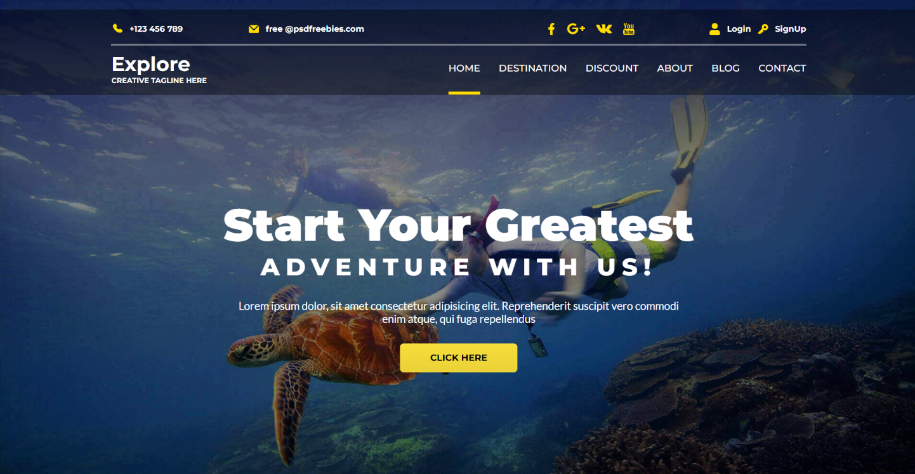**Results**

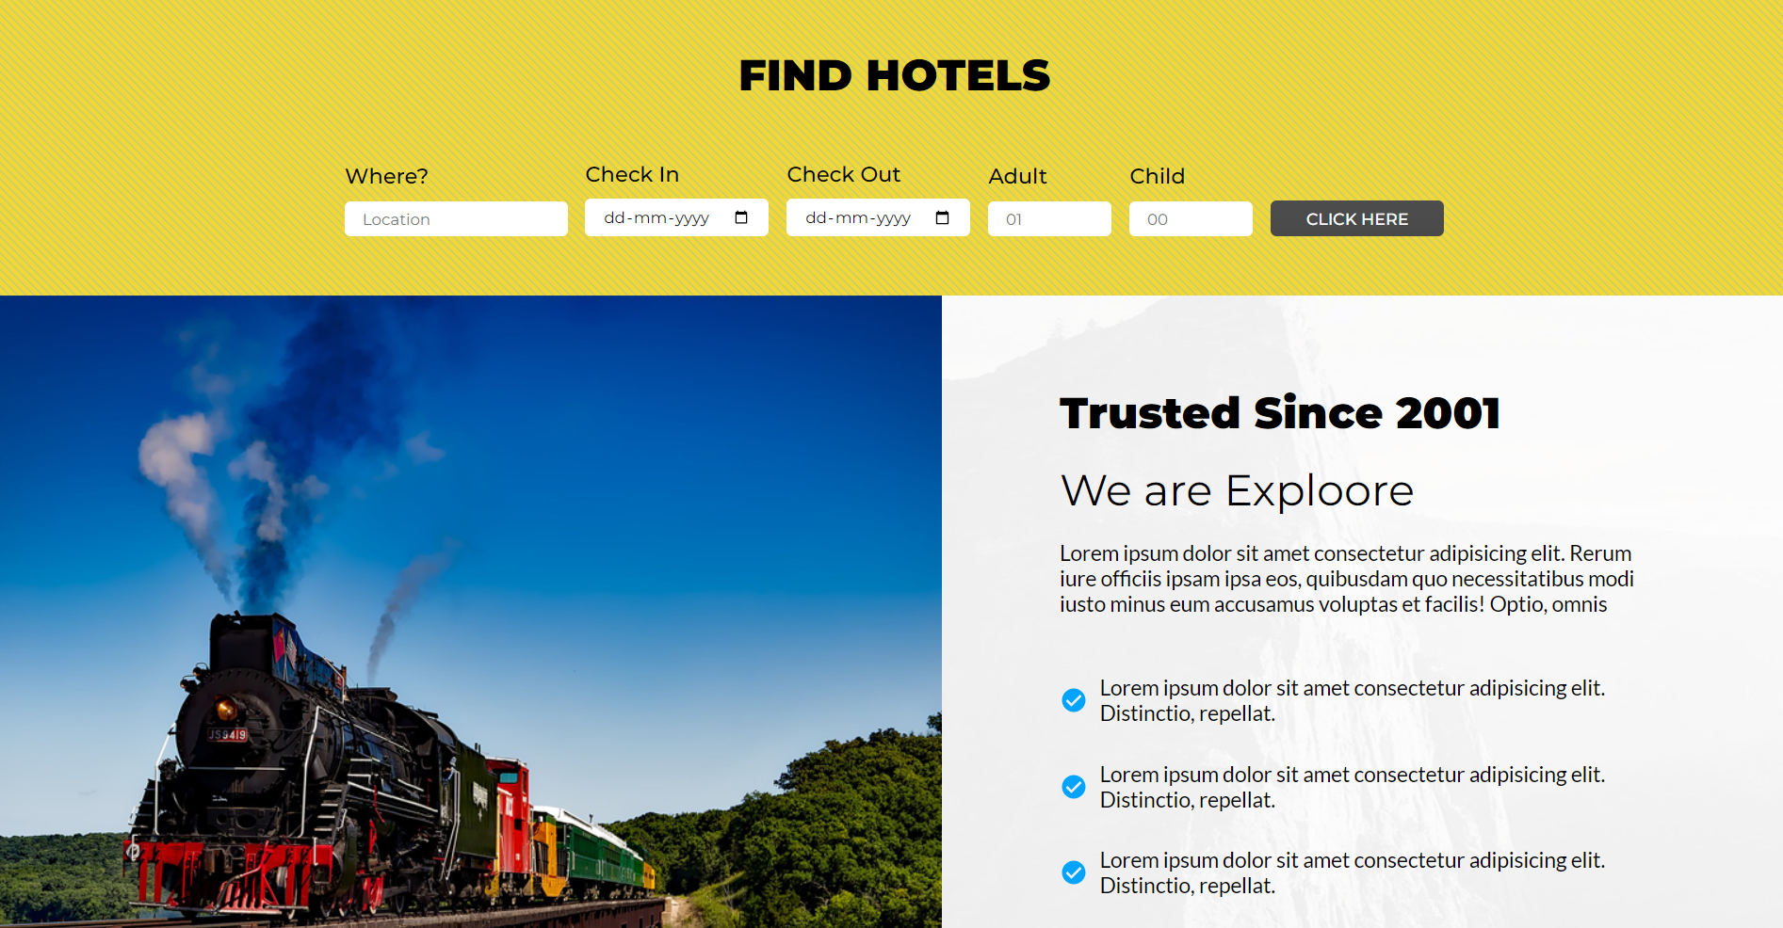

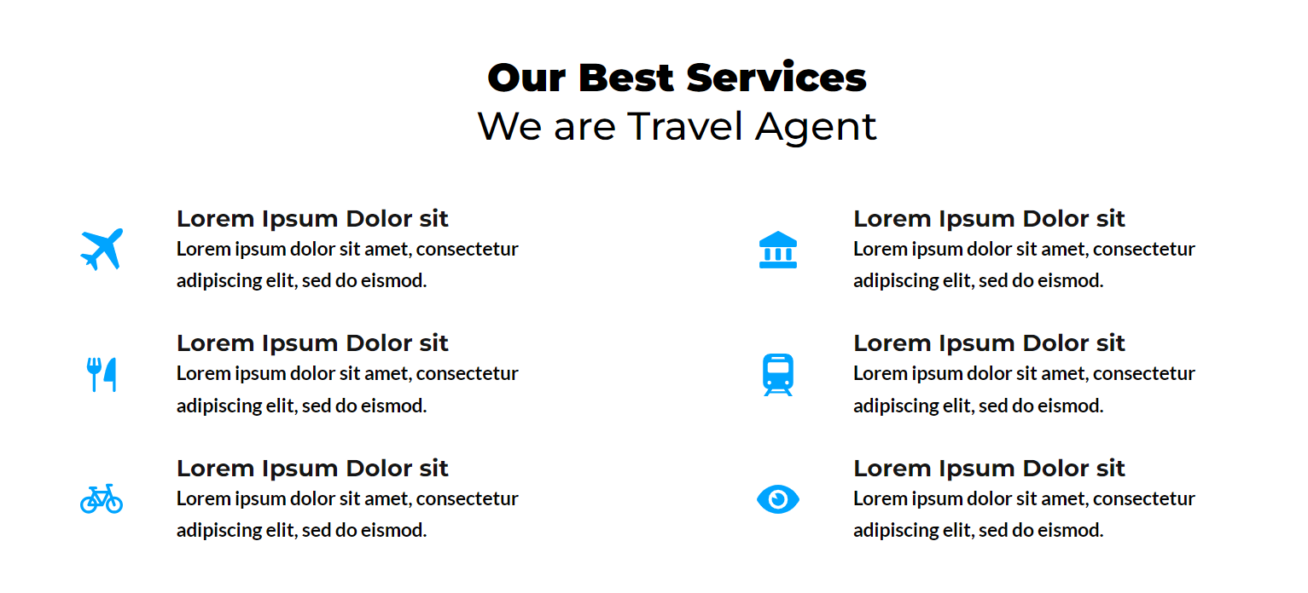

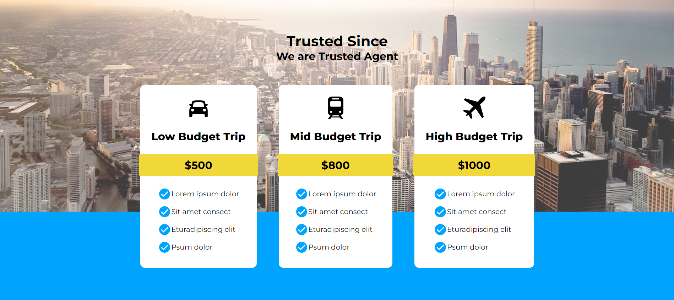

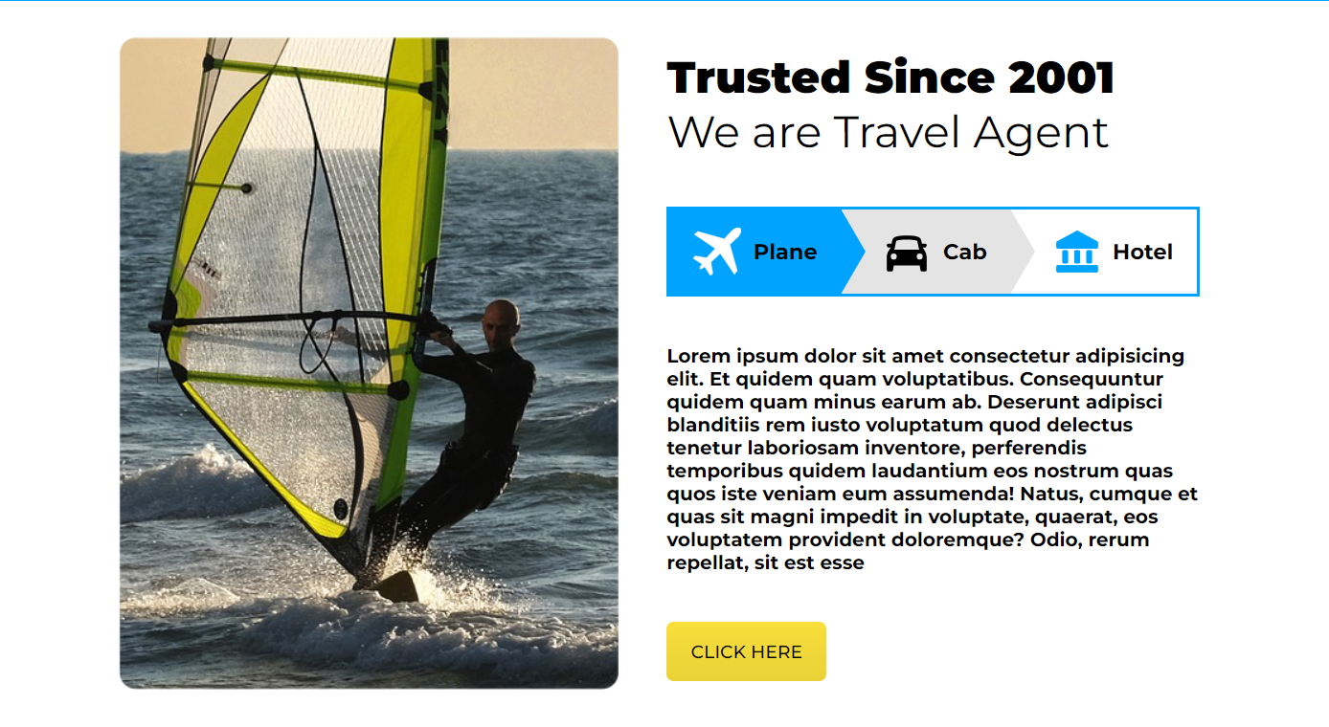

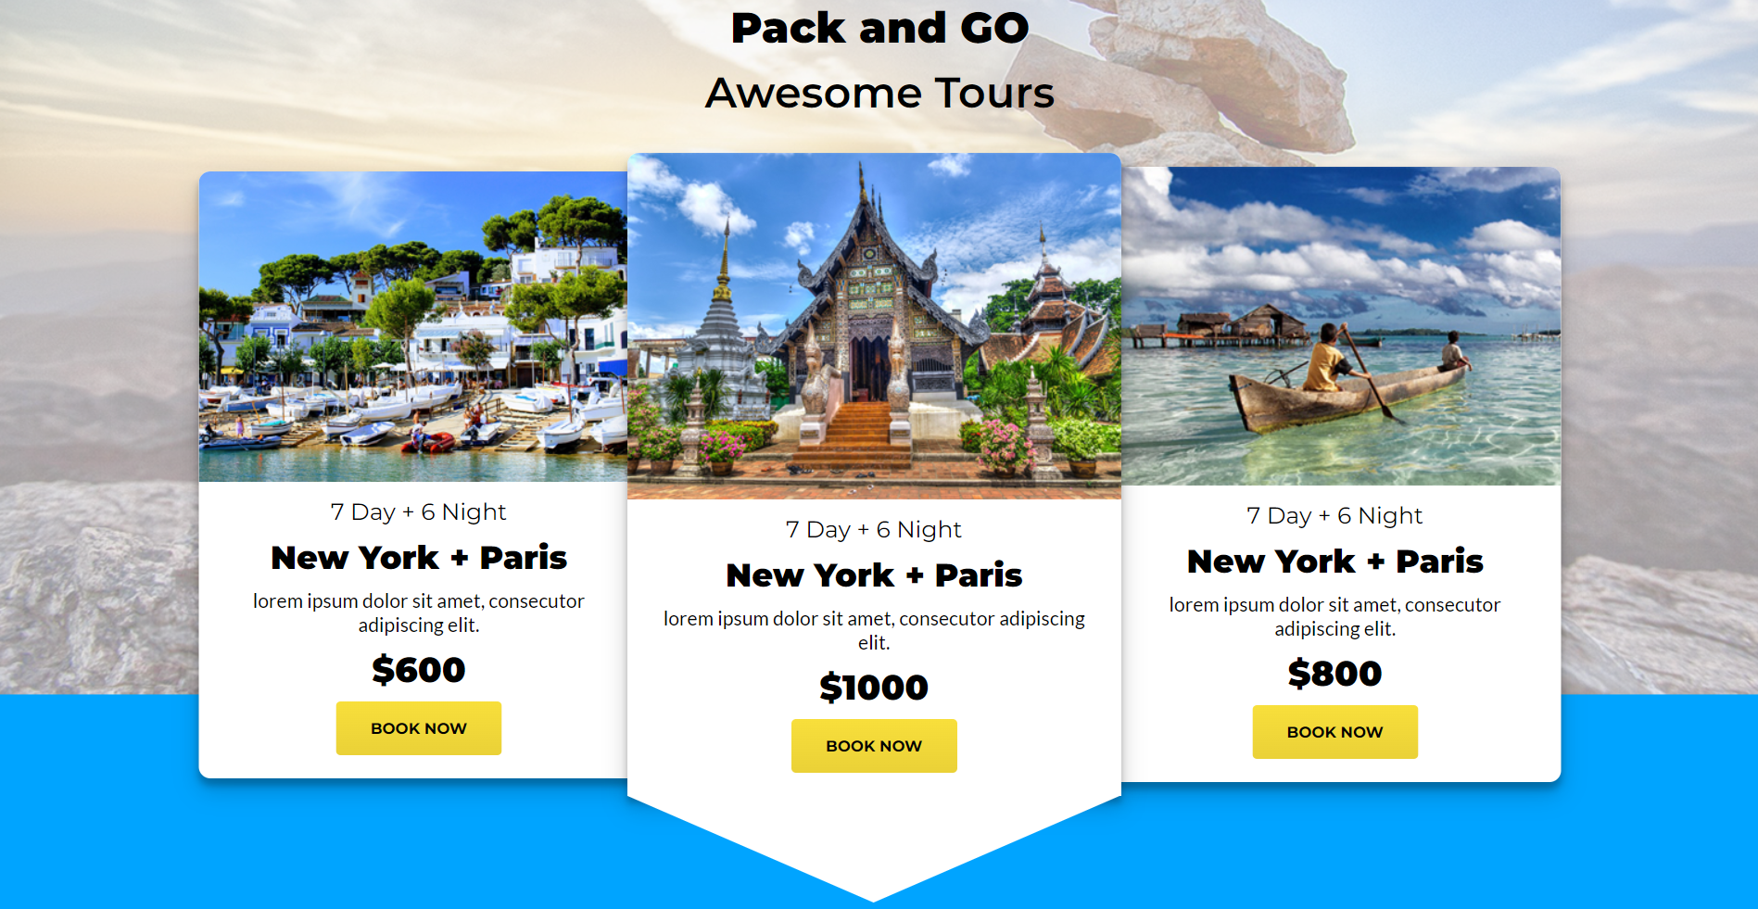

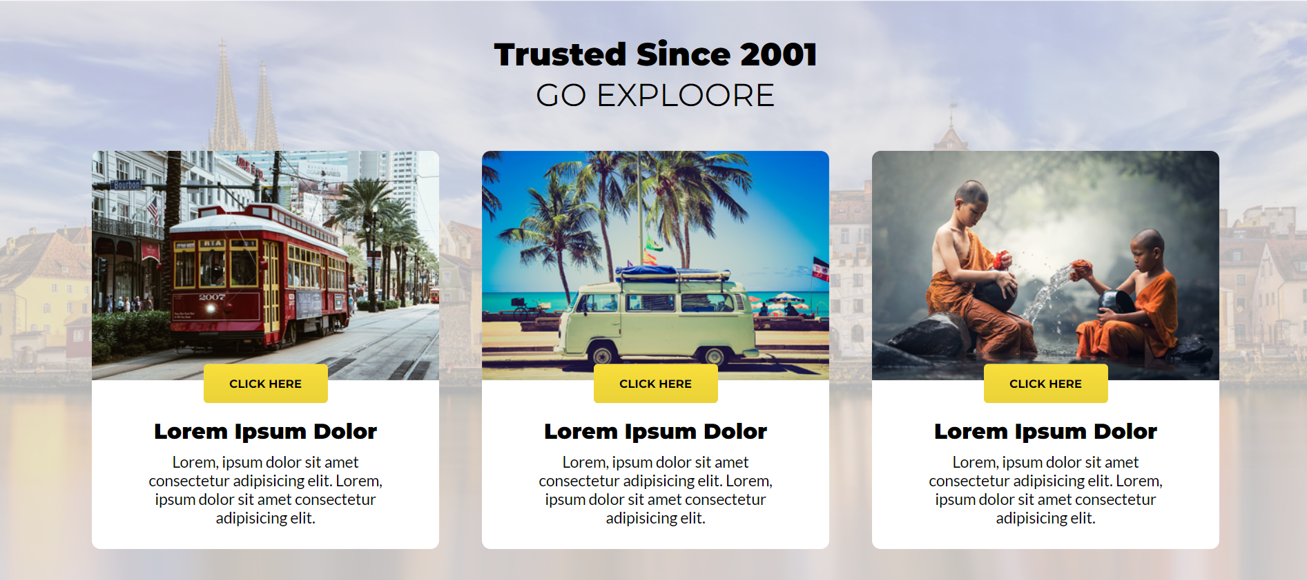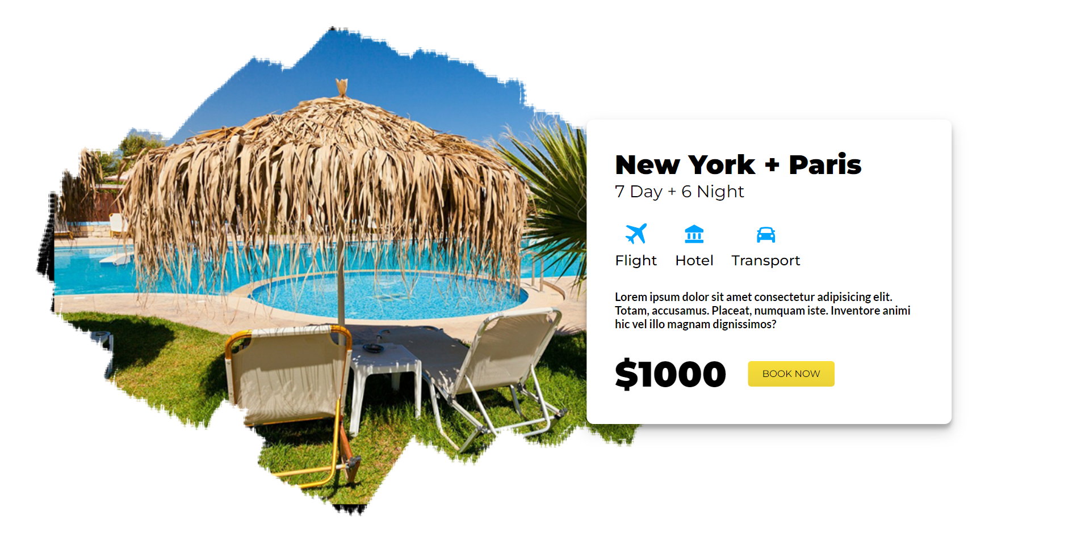

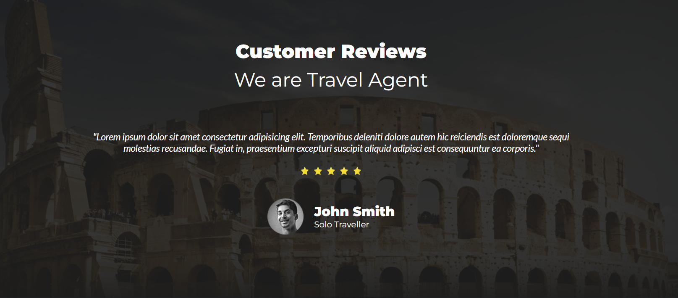

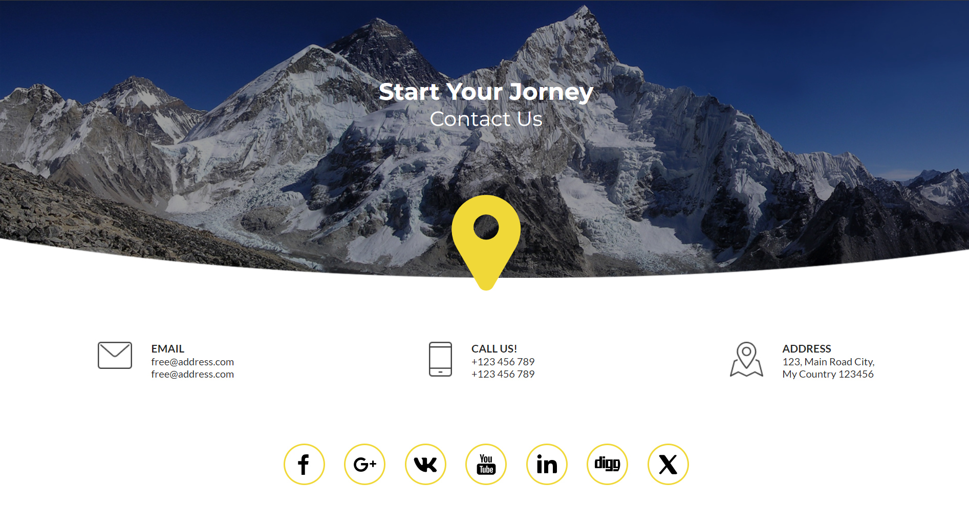

**References**

* + **React Docs:** <https://react.dev/>
  + **Javatpoint:** <https://www.javatpoint.com/>
  + **Geeks For Geeks:** <https://www.geeksforgeeks.org/>
  + **ChatGPT:** <https://chatgpt.com/>
  + **W3Schools:** <https://www.w3schools.com/>